8. Data & Persistence Baseline

8.1 Entity Overview
From milestone 1, the separate roles such as requester, front-line staff, department supervisors, senior management, and system administrator have been merged into a single entity known as the “user” to ensure simplicity. However, to distinguish between different user types, a “user_type” attribute will be introduced to only include three roles which are requester, staff (front-line staff), and management (department supervisor, senior management, and system administrator). In addition to that, “service_request” entity represents the request(s) made by requesters, the “action” entity will act as the audit trail for staff actions, and the “logging” entity will be used to store initiated SQL triggers.
Entity | Purpose | Owning Module | Lifecycle
user | One entity representing requester, staff, and management. Category attribute will only contain data if the user type is staff, otherwise it stays null. | User module | Registered (REQ-023) → Active
service_request | One entity representing the service request made by the requester which contains title, description, start date, end date, category, status, creation date, and street address (REQ-001–REQ-003). | Request module | Pending → Accepted/Assigned → In Progress → Completed/Resolved, or Rejected/Closed
action | Audit trail that records actions of staff regarding service requests to save actions, date, new status, and comments (REQ-014, REQ-021) | Request module | Creation
logging | Logging that takes place to store records that have faults in using CRUD operations on user, service_request, and action entities. If an error occurred, the logging table will show exactly who made the mistake, what it was, where, when, and how. | Persistence Module | Trigger-generated

8.2 Initial Model
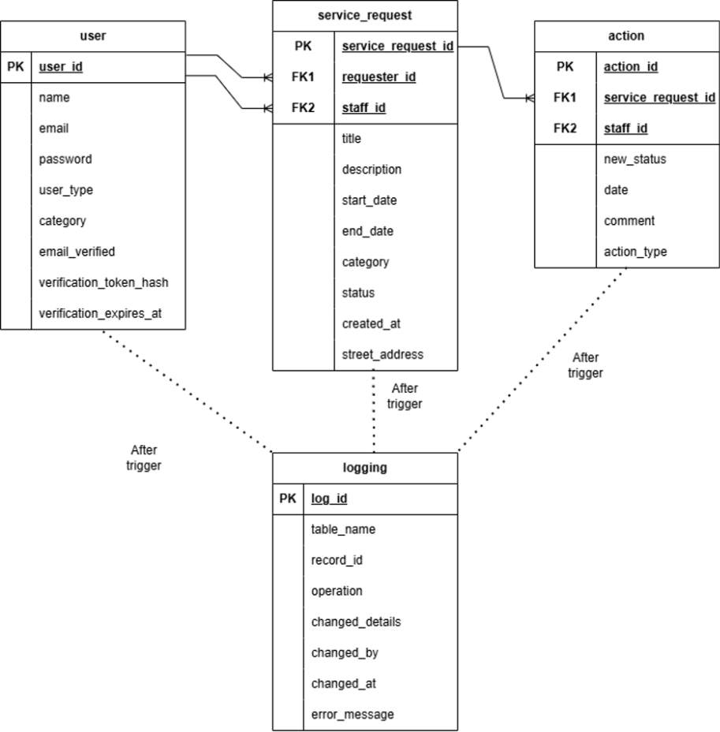

8.3 Justification of Persistence Model
 | Structure | Relationships | Access Patterns | Integrity | Consistency | Sensitivity | Growth
user | Fixed, tabular (user_id, name, email, password, user_type, category, email_verified, verification_token_hash, verification_expires_at); variation in records won’t exist even if user_type exists. | One-to-many with service_request, both requesters and staff use user_id as foreign key and one-to-many for action entity, where only staff connect to via user_id foreign key. | At every login the email and password must be read, user_type must always be read during requests to ensure RBAC, and category is only read if user is a staff, verification_token_hash is only read once during initial registration. | The email attribute should be unique, and password should never be stored as simple text; user_type contains already fixed set of values to avoid wrong role assignment. The email_verified is set to true if the user has successfully confirmed registration. | A role check must be executed to ensure the user is not assigned to the wrong role. A token check must ensure that the right user retrieves the 6 digit-code for verification_token_hash via email. The verification_token will lose validity if it expires based on the verification_expire_at. | The sensitive data of every user will not be exposed to other users. However, management will be able to view staff actions which expose their IDs only. Only the specified user must receive the verification token at registration. | Linear growth depends on user registrations but low with regards to service_request and action.
service_request | Fixed, tabular (service_request_id, requester_id, staff_id, title, description, start_date, end_date, category, status, created_at, street_address); no variation in records. | Many-to-one with user two times (requester_id and staff_id both reference user.user_id); one-to-many with action via service_request_id. | The request is only created once by the requester and read by the requester and the assigned staff. The management will also read all requests frequently to check work progress. | Status must have a logical order to transition (e.g. pending to accepted to completed), end_date cannot be older than start_date, and requester_id and staff_id must reference real users with correct user_type. | The Timestamp locking protocol must ensure that consistency takes place to stop two staff trying to claim responsibility for a single service request at the same time, strengthened by A2 research. | Service request information should only be shown to assigned staff, whereas management can view all service request data. Requesters may not see other requests. | Growth expected to be the highest among the four entities.
action | Fixed, tabular (action_id, service_request_id, staff_id, new_status, date, comment, and action_type); no variation in records. | Many-to-one with service_request (service_request_id) and with user (staff_id), also ensuring that the user_type must be staff before it can be related to action entity. | Actions are automatically created whenever status update or a new comment occurs; only management reads this for accountability. | Action records cannot be changed once added; staff_id and service_request_id must link to real records. | Consistency is not strict here since business rules are not affected by delay of action “audit” insertions. | Management is the only role which is allowed to access audit actions for oversight and accountability. | Growth can be growing fast depending on how many comments or status updates are made per request.
logging | Fixed, tabular (log_id, table_name, record_id, operation, changed_details, changed_by, changed_at, error_message); logs are written whenever a SQL trigger occurs, the users won’t be able to perform it. | The logging entity is not linking to user, service_request, and action; table_name and record_id identifies the rows that are affected without requiring referential integrity. | Whenever logging inserts new logs, it will only be seen during debugging and development and not on the CivicConnect platform; only when a bug occurs. | As soon as trigger fires, changed_details will be recorded to show what changed; changed_by and changed_at are added automatically; a record cannot be ignored if bug occurs since it records bug actions. | Since logging does not affect the operations taking place for user, service_request or action, its logs can be delayed; consistency is relaxed. | Records that the logging entity logs should not expose sensitive data in the logging table; only the necessary details that aid in successful debugging. | The growth of logging is fast since developers are expected to make many mistakes in code; for every bug – new log record.

8.4 Conclusion
The four entities are fixed, structured, and involved in relationships (via user_id and service_request_id as foreign keys) which need to aid querying information via joins. Merging requester, staff, and management into a single entity called user reduced complexity. However, RBAC must be enforced using the user attribute “user_type” to categorize user roles instead of relying on which user belongs to which table. Access patterns are heavy when it comes to read operations for user and service_request as well as for authenticating users via verification tokens and stopping simultaneous updates to service_request, action accepts consistency to be relaxed and is seen as insert-only whereas logging entity is also relaxed with trigger-only function. Taking this into consideration, these features fit relational databases which is strengthened by A2 research describing that relational databases require integrity constraints, security, strong consistency, fixed tables, and table dependencies. Therefore, based on these features listed and A2 research, PostgreSQL, which is a relational database, is best suited for the CivicConnect platform. However, a trade-off would be that changing requirements impact fixed schemas.

8.5 Bottlenecks, SPOF, Scalability, Availability, and Backup/Recovery

8.5.1 Single Point of Failure (SPOF)
If only a single database lives for the CivicConnect platform and it fails, all operations performed on the platform will fail as well; every user cannot log in, requesters cannot submit requests, staff cannot make updates to the service requests, and management does not receive full visibility of actions recorded for audit trail. The logging entity will also fail, since it stores bugs that occurred in application development; it is not there to save records when database is down. Therefore, to solve this issue, a standby database can be added alongside the main database, mirroring precise actions of it, so that it can take the main database’s place if failure occurs for it.

8.5.2 Scalability
Entities that are expected to grow fast are service_request, action, and logging. The service_request grows for every added request, action grows more for every status update or new comment, and logging grows for every bug found when developer attempted CRUD operations across 3 tables. If these are not addressed, it brings two bottlenecks:
Read bottleneck: Service requests are frequently filtered by management and staff using date, staff ID, or status. This issue may be resolved using indexes for staff_id, requester_id, and status for service_request, whereas indexes can be applied to action using service_request_id and date.
Write bottleneck: If retention policies for the database are not taken into consideration, and action and logging entities continue to perform many write volumes, records can be archived depending on their retention period, removing them from the primary database completely.

8.5.3 Availability
The target of availability should aim for 99.9%, which is referenced from REQ-034/ASR-004 with the aid of database failover operation if the main database is down.

8.5.4 Backup and Recovery
Backups are manually backed up weekly for databases to be restored in that timeframe. The service_request and action entities contain most write operations; they require the highest priority for backup, ensuring that their tables are restored in correct manner. If they fail, they will not be supporting the active and seeable audit trail that is managed by management personnel. Since logging only concerns about diagnostics and not operational purposes, losing its data will not affect the platform data itself; lowering its backup/restoring priority to low.

